COMP3064 – Assignment 1

Nooran El-Sherif – 100695733

October 20, 2017

Abstract

External documentation for the Bee Game. Includes description of game mechanics, controls and diagrams of the game.

Bee Game

External Documentation

Table of Contents

[Intro 2](#_Toc496262900)

[Detailed Game Description 2](#_Toc496262901)

[Controls Description 2](#_Toc496262902)

[Wireframes 3](#_Toc496262903)

[Screenshots 4](#_Toc496262904)

[Start State 4](#_Toc496262905)

[Gameplay State 4](#_Toc496262906)

[Game-End State 4](#_Toc496262907)

[Enemies 5](#_Toc496262908)

[Scoring 5](#_Toc496262909)

[Sound Clips 5](#_Toc496262910)

[Art and Multimedia 6](#_Toc496262911)

# Intro

An evolutionary instinct drives Bob the Bee to collect nectar from flowers. To do it he will have to avoid the bees from other hives, who are not friendly. If he runs into a bee from another hive, he will have to use one of his three stingers to kill it. After the third stinger, Bob can no longer survive and the game is over.

# Detailed Game Description

* Bee moves in the screen from left to right
* If the Bee moves to the boundaries of the screen, it does not exit the screen, instead it will stay at the boundary
* The Bee has 3 Stingers. When the Bee hits an Enemy Bee 3 times, the game is over
* If the Bee hits an Enemy Bee, the Bee loses a Stinger and the Enemy Bee disappears
* If the Bee hits an Enemy Bee, the Bee flickers but is not immune.
* If the Bee hits a flower, the flower disappears and the score increases by 1 point/ 1 mL of “nectar”

# Controls Description

* If the W button is pressed the Bee moves up in the screen
* If the A button is pressed the Bee moves left in the screen (backwards)
* If the S button is pressed the Bee moves down in the screen
* If the D button is pressed the Bee moves right in the screen
* If the Reset Button is pressed when the game is over, the game restarts

# Wireframes

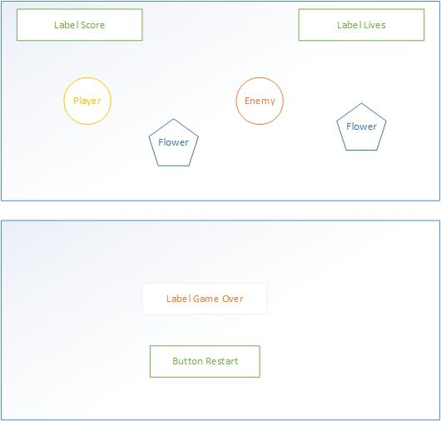

# Screenshots

## Start State

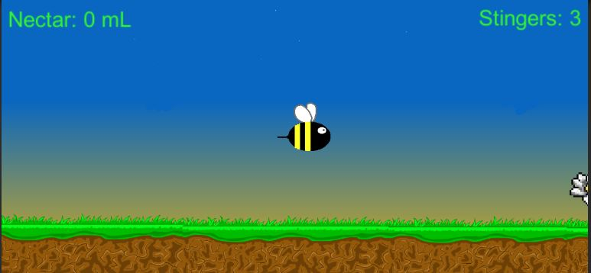

## Gameplay State

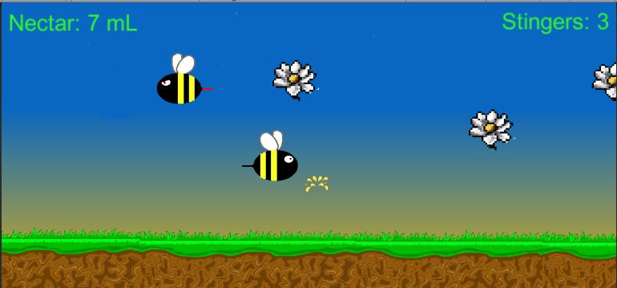

## Game-End State

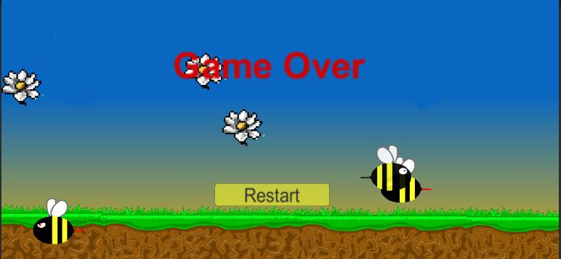

# Enemies

The enemies in this game are “Enemy Bees”, bees traveling in the opposite direction of the player bee. The Enemy Bees appear at the right boundary of the screen. The location they appear on the y-axis is randomized so they don’t always come from the same direction. The speed of the bee is also randomized between 7 and 10 float. The X position they appear is also randomized, using the boundary of the right of the screen and adding a random number between 0-100. This makes it so that they appear further or closer to the boundary, making their appearance a bit more unpredictable. The Enemy Bees are instantiated while the game is running using a Coroutine that waits between 3-10 seconds, then introduces a new Enemy Bee.

# Scoring

The player collects nectar from flowers by running into the flowers with their Bee. For every flower that is collected, one point (1 mL of nectar) is added to the player’s score. The score is calculated by adding 1 to the score for every collision with a flower.

# 

# Sound Clips

|  |  |
| --- | --- |
| Sound Clip Name | Description |
| BeeGame.mp3 | The background music for the game. It plays continuously |
| BeeGameBuzz.mp3 | A buzzing sound that plays when the Player collides with an Enemy |
| BeeGameSlurp.mp3 | A slurp sound that plays when the Player collides with a Flower |

# Art and Multimedia

|  |  |
| --- | --- |
| Image Thumbnail | Description |
| C:\Users\nooran\AppData\Local\Microsoft\Windows\INetCache\Content.Word\background.png | The background image of the game. A simple sky and ground. |
| C:\Users\nooran\AppData\Local\Microsoft\Windows\INetCache\Content.Word\bee.png | The Bee that represents the Player. |
| C:\Users\nooran\AppData\Local\Microsoft\Windows\INetCache\Content.Word\enemy_bee.png | The Enemy Bee. It has angry eyes and a red stinger to distinguish it from the Player Bee. |
| C:\Users\nooran\AppData\Local\Microsoft\Windows\INetCache\Content.Word\droplet.png | Droplet Animation for when nectar is collected from flowers. |
| C:\Users\nooran\AppData\Local\Microsoft\Windows\INetCache\Content.Word\flower6.png | Flower that the Player collects nectar from. |